
The Desert Resort
  - Website objective and Business Goals
  - About us
The Desert Resort is an organization amid to bring the absolute best of what African tourism has to offer and bring divers personal from all over the world for a once in a lifetime experience.
  - Website specifications:
Objective
The primary objective of this website is to provide a seamless digital gateway to luxury desert tourism nonnative or for foreigners visiting for an experience they will never forget.
  - Goals
- Brand Awareness: Establish high-end digital presence that reflects the exclusivity of the resort.
- Lead Generation: Convert visitors into guests through an integrated booking and inquiry system.
- Information Hub: Serve as the definitive source for accommodation details, safari activities, and resort amenities.
  - Target Audience (Demographics & Technical Aptitude)
Demographics: International and local luxury travelers aged 25-65. Typically, high-income earners (HNWIs), honeymooners, adventure enthusiasts.
Technical Aptitude: High, User can expect to be proficient with mobile device and desktop browsing, expecting fast load times and intuitive UI/UX.
  - Website Type and Content
The site is a Commercial/Hospitality Service Website. Contact includes high-resolution images galleries, virtual tours, a dynamic booking Calander, and blog post detailing local safari flora and fauna.
  - Information Design & Taxonomy
The website follows a hierarchical taxonomy to ensure guests can find information within three clicks.
Information Architecture (Site Map):
- Home: Hero video, quick-book widget, featured testimonials.
- Accommodation/Explore suits: Luxury Tents, Private suites, Family Villas.
- Experiences: Dune Bashed Tours, Stargazing, Camel Safaris, Family Villas.
- Gallery: Visual showcase of the resort and surroundings.
- Contact/Booking: inquiry forms and Booking forms.
Storyboard Flow.
Desert & Delta: HTTPs://desertdelta.com/ used the picture and video layout as reference.
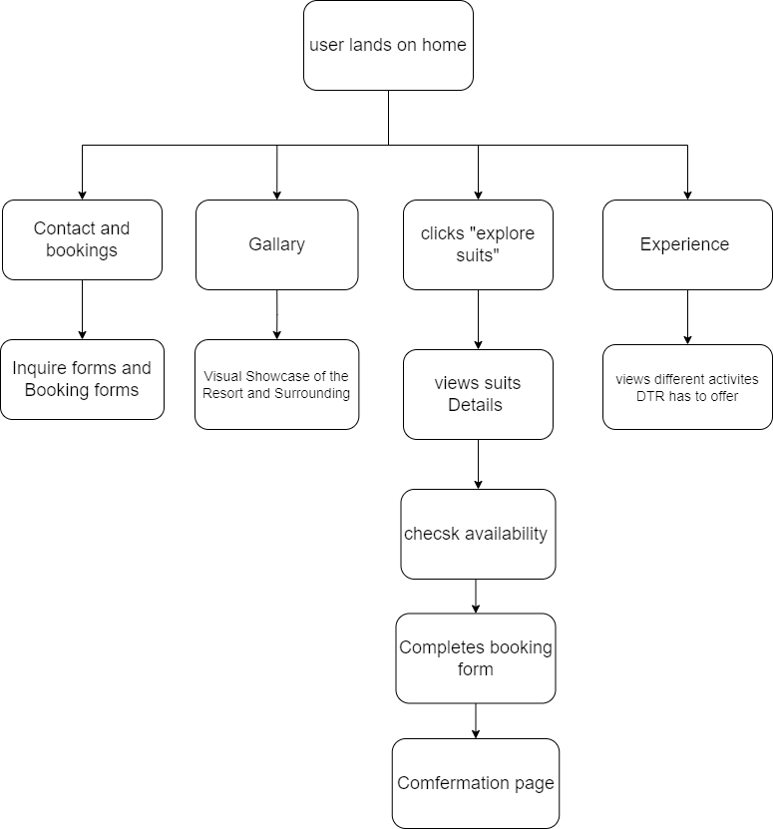
  - Storyboard Flowchart:
  - Technical Brief
To Match the resort’s premium nature, the following stack can be used:
- Frontend: HTML5, CSS3(using Flexbox/Grid for responsiveness), and JavaScript (ES6) for interactive elements.
- The look and design of the webpages is created by us using the listed above HTML being the structure, CSS3 the look e.g., “colors and layout and JavaScript” functionality.
- Graphics Tools: Adobe Photoshop for image optimization and Figma for UI/UX prototyping.
    - These tools help create images and graphical interfaces used to enhance the website for a more appalling look and feel.
- Frameworks: Bootstrap five for rapid responsive grid deployments.
    - For the responsive grid placement or the arrangement of the grid laces e.g., the Navigation and pictures on the website
- Version Control: Git for managing codebase iterations.
      - Is used to store and operate the website from one place without mismanaging or loss of data and smooth operation of the website.

  - Promotion and Publishing

Promotion
- Visual Storytelling: Use the high-resolution images and virtual tours to create “Experiences Reels “on social media.
- Targeted Ads: To target interests from high-net-worth individuals and any looking to stay in a luxury resort.
- First access bookings: Allow customers to have easy access to the resort and spread positive words to other potential customers that can bring and lead generation to the resort.
Publishing
- Performance Teasing: Highlighting the fast load times and responsiveness of the webpage and content it has to offer for The Desert Resort.
- Local & International PR: Send our “About us” mission to luxury travel magazines to spread awareness of and focus on “The New Standard of African Tourism.”
- Social Proof: We Publish our Featured Testimonials on our home pages to build trust with international travelers.

